Family Promise Expansion
Thanks to National Family Promise Expansion Grant we are now able to help serve Townsend and Broadwater County families! Broadwater County Development Corporation is thrilled that we will be helping families in that area and have welcomed us with open arms. The Broadwater County Commissioners matched our initial grant with another $8000. We will have an office in the Community beginning October 1, located at 200 N Cedar, the United Methodist Church in the lower level. Initially we will have limited office hours at the location. We have already helped 2 families from becoming homeless!

Prevention and Diversion Program
Our new Prevention and Diversion program is still going strong with some amazing grants that we have received. From January to July we served 26 families with 64 children! That means 26 families that did NOT become homeless!

Families served
We continue to have guest families that participate with Family Promise and stayed overnight at the churches. As of August 2022 we have housed 8 families! We have 6 guest families now and are hoping to have them housed before the holidays, which are approaching soon! Three of our guests are 2 years of age, so it is never a dull moment at the day center!

Renee Bauer, Executive Director
Kimberly Woods, Family Advocate
Ashley Moniz, Community Services
September 2022

Comfort Food BBQ/Picnic
What a wonderful turnout, even with the wind! Hopefully next year we will be able to have it indoors! The Trophy this year for best food award went to St. Paul’s United Methodist!
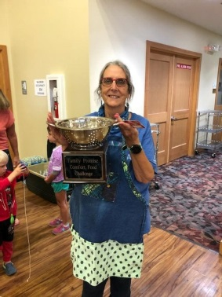
Pictured: Marcia Armstrong accepting trophy

Welcome our New Employee
Please welcome our part-time employee, Ashley Moniz, as our Community Services Administrator! She comes to us with much knowledge of community programs within the Greater Helena Area! We are excited to have her!

Coming Soon!
John Floridas Christmas Concert
At St. Paul’s United Methodist Church
December 13th,2022 at 7:00pm

check out our website: www.familypromisehelena.org

